Contents

1 EASTERN CAPE RESULTS 2

1.1 TEMPERATURE 2

1.1.1 Pettitt test 2

1.1.2 Mann-Kendall & Sen’s slope 3

1.1.3 Temperature Concentration Index 4

1.2 PRECIPITATION 5

1.2.1 Pettitt test 5

1.2.2 Mann-Kendall & Sens slope 6

1.2.3 Modified Fournier Index 7

1.2.4 Precipitation Concentration Index 9

# 1 EASTERN CAPE RESULTS

Eastern Cape province has 3-gauge stations: Tsitsikamma, Cape Francis and East London. The analysis is done for all the 3 stations.

# 1.1 TEMPERATURE

## 1.1.1 Pettitt test

The nonparametric Pettitt test is a technique of detecting significant change points as mentioned in chapter 2. The nonparametric Pettitt test does not consider the distribution the data follows. The significant change points would be identified where the p-value is less than 0.05 at a 5% significance level. Considering the South African Weather Services data, I find that there are change points, and they are indicated in the tables below, table 1 and table 3. Therefore, it is evident that there are change points in both precipitation and temperature. Please note that the tables only display the results of the significant change points (p-value < 0.05).

As seen in table 1 that all of the abrupt changes are upwards, there is abrupt increase in the temperature over the years. Out of the 3 stations, only East London has no change point on all timescales. East London signifies that no abrupt changes in the temperature was experienced.

Table 1: Pettitt test results for temperature

|  |  |  |  |  |  |  |
| --- | --- | --- | --- | --- | --- | --- |
| **Timescale** | **Gauge Station** | **P-value** | **Change point** | **Average Before shift** | **Average After shift** | **Shift** |
| March | Tsitsikamma  Cape Francis | 0.0009  0.0211 | 2008  2015 | 23.4  21.0 | 24.8  22.8 | UP  UP |
| May | Tsitsikamma | 0.0173 | 2007 | 20.9 | 24.1 | UP |
| June | Tsitsikamma  Cape Francis | 0.0184  0.0211 | 2006  2015 | 19.6  18.5 | 21.6  21.1 | UP  UP |
| August | Tsitsikamma | 0.0350 | 2006 | 17.6 | 19.3 | UP |
| September | Tsitsikamma  Cape Francis | 0.0004  0.0145 | 2007  2013 | 19.7  18.0 | 21.2  19.0 | UP  UP |
| October | Tsitsikamma | 0.0071 | 2010 | 20.8 | 23.0 | UP |
| Winter | Tsitsikamma  Cape Francis | 0.0007  0.0098 | 2007  2015 | 20.5  18.6 | 21.8  19.5 | UP  UP |
| Spring | Tsitsikamma | 0.0003 | 2007 | 19.8 | 21.1 | UP |
| Summer | Tsitsikamma  Cape Francis | 0.0184  0.0429 | 2010  2014 | 23.6  21.6 | 25.0  23.2 | UP  UP |
| Autumn | Tsitsikamma  Cape Francis | 0.0017  0.0075 | 2008  2015 | 22.5  20.6 | 24.4  22.7 | UP  UP |
| Annual | Tsitsikamma  Cape Francis | 0.0001  0.0098 | 2008  2015 | 21.9  20.5 | 22.3  21.2 | UP  UP |

## 1.1.2 Mann-Kendall & Sen’s slope

The Mann-Kendall trend test examine whether the trend in a time series data exists, and the Sen’s slope measures the direction and magnitude of the trend given the trend exists. It is said that the trend exists if the p-value is less than 0.05 and calculated Z statistics is greater than the critical value |1.645| at a 5% significance level. Figure 1 is provided below to display the Z test statistic for 3 stations for different timescales.

Table 2: Mann-Kendall test results with Sen's slope coefficient for temperature

|  |  |  |  |  |  |
| --- | --- | --- | --- | --- | --- |
| **Timescale** | **Gauge Station** | **P-value** | **Z value** | **Sen’s slope** | **Trend direction** |
| January | Tsitsikamma | 0.0379 | 2.06 | 0.044 | Upwards |
| March | Tsitsikamma | 0.0006 | 3.44 | 0.062 | Upwards |
| June | Tsitsikamma  Cape Francis | 0.0008  0.0142 | 3.37  2.45 | 0.100  0.15 | Upwards  Upwards |
| July | Tsitsikamma | 0.0018 | 3.13 | 0.075 | Upwards |
| September | Tsitsikamma | 0.0001 | 4.57 | 0.076 | Upwards |
| October | Tsitsikamma | 0.0012 | 3.25 | 0.067 | Upwards |
| September | Cape Francis | 0.0116 | 2.53 | 0.073 | Upwards |
| November | Tsitsikamma | 0.0164 | 2.40 | 0.044 | Upwards |
| Winter | Tsitsikamma  Cape Francis  East London | 0.0003  0.0209  0.0446 | 3.66  2.31  2.01 | 0.075  0.079  0.040 | Upwards  Upwards  Upwards |
| Spring | Tsitsikamma | 0.0001 | 3.91 | 0.069 | Upwards |
| Summer | Tsitsikamma | 0.0143 | 2.45 | 0.059 | Upwards |
| Autumn | Tsitsikamma  Cape Francis | 0.0068  0.0459 | 2.70  2.00 | 0.043  0.056 | Upwards  Upwards |
| Annual | Tsitsikamma  Cape Francis | 0.0001  0.0227 | 4.50  2.28 | 0.063  0.078 | Upwards  Upwards |

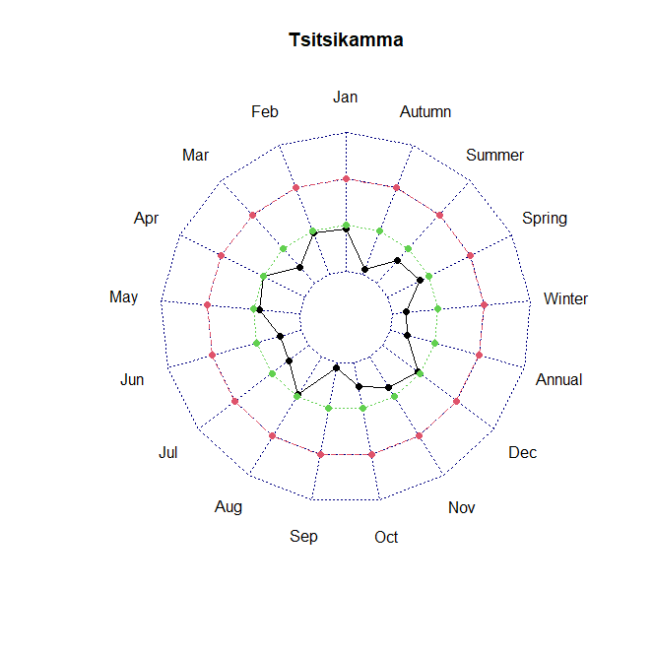

Figure : Mann-Kendall trend results for temperature

## 1.1.3 Temperature Concentration Index

TCI is a new index for displaying the uniformity distribution of temperature that the basic idea is derived from the PCI. The classification table is given in chapter 2. For all the stations have a TCI index which is less than 10, indicating that the temperature is uniform for all the stations which indicates that for whole province of the Eastern Cape the temperature has a uniform distribution pattern.

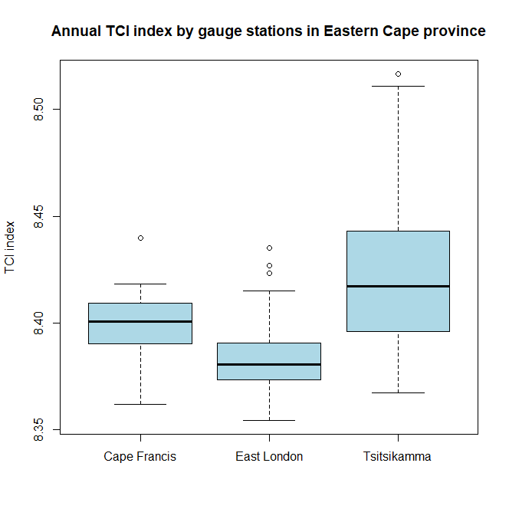

Figure 2: TCI results for temperature

# 1.2 PRECIPITATION

## 1.2.1 Pettitt test

A brief description of Pettitt test is given in section 1.1.1. Table 3 indicates only one abrupt change in Tsitsikamma for the annual timescale. Out of the 3 stations only Tsitsikamma has abrupt change and the change in upwards.

Table 3: Pettitt test results for precipitation

|  |  |  |  |  |  |  |
| --- | --- | --- | --- | --- | --- | --- |
| **Timescale** | **Gauge Station** | **P-value** | **Change point** | **Average Before shift** | **Average After shift** | **Shift** |
| Annual | Tsitsikamma | 0.025 | 2002 | 38.6 | 72.1 | UP |

## 1.2.2 Mann-Kendall & Sens slope

As indicated in table 4, East London has no significant trend. Cape Francis has downward abrupt change while Tsitsikamma has upward abrupt change in spring, winter and annually.

Table 4: Mann-Kendall test results with Sen's slope coefficient for precipitation

|  |  |  |  |  |  |
| --- | --- | --- | --- | --- | --- |
| **Timescale** | **Gauge Station** | **P-value** | **Z value** | **Sen’s slope** | **Trend direction** |
| April | Cape Francis | 0.0424 | -2.03 | -2.09 | Downward |
| Winter | Tsitsikamma | 0.0489 | 1.97 | 0.849 | Upward |
| Spring | Tsitsikamma | 0.0340 | 2.12 | 1.354 | Upward |
| Annual | Tsitsikamma | 0.0232 | 2.27 | 0.776 | Upward |

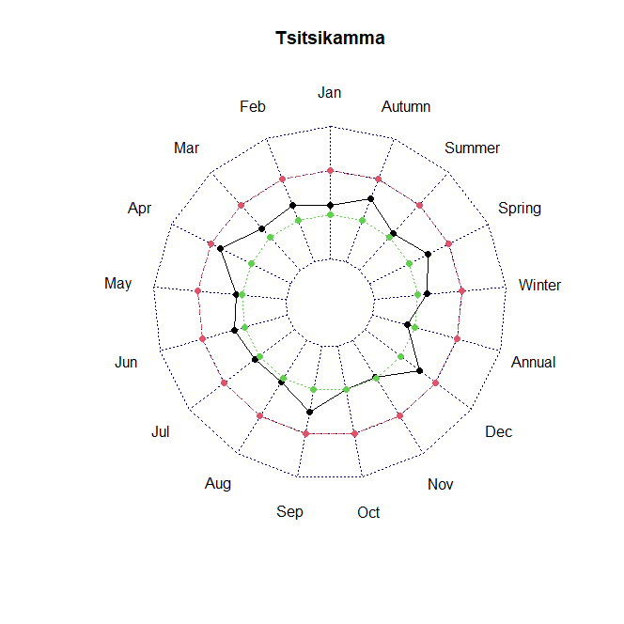

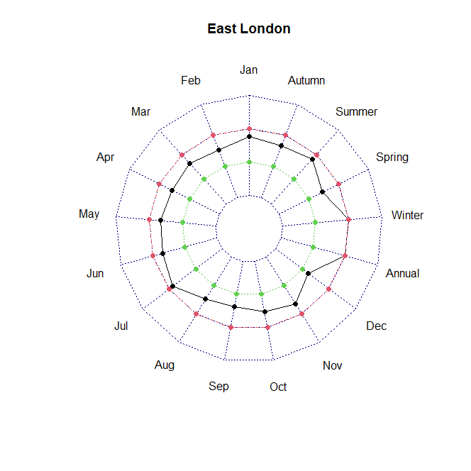

Figure 2: Mann-Kendall trend test results for precipitation

## 1.2.3 Modified Fournier Index

As previously mentioned in Chapter 2, MFI is used to measure the erosivity power of rainfall. In chapter 2, section 2.6, a table is provided to classify the aggressiveness of the rainfall. Below is the figure 3 that shows MFI for each station. The red line is the cut off value of 120, for which, any MFI above this value shows rainfall aggressiveness. The rainfall is very severe in East London mostly while Tsitsikamma and Cape Francis have a low to moderate rainfall aggressiveness.

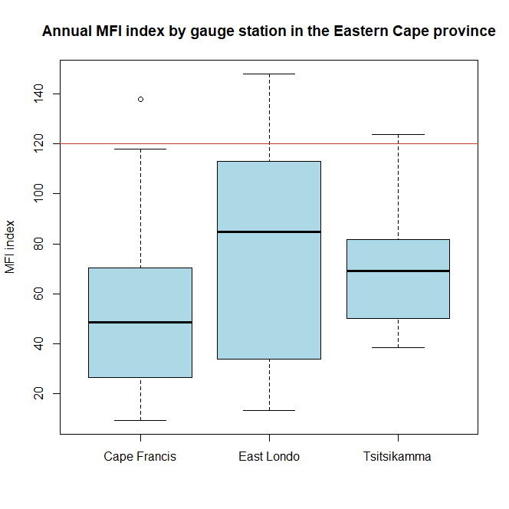

Figure 3: MFI results for precipitation

## 1.2.4 Precipitation Concentration Index

PCI, as explained in the first chapter, that, is a powerful indicator for temporal precipitation distribution and is traditionally applied on an annual scale. The classification table is given in chapter 2. According to the figure 4, Tsitsikamma has a uniform to adequate precipitation concentration while East London and Cape Francis have a adequate to irregular precipitation concentration.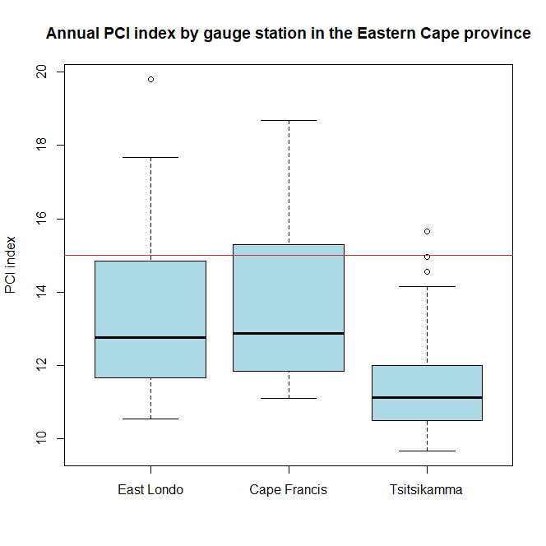

Figure 4: PCI results for precipitation